

|  |  |  |  |  |  |  |  |  |
| --- | --- | --- | --- | --- | --- | --- | --- | --- |
|  | | | | | | | | |
|  | | Lab 02 | Configuring a VPN Server with pfSense | | | | |  | |
|  |  | | | | | | |  |
|  | | | |  |  | | | |
|  | | | | Cesar Munguia |  | | | |
|  | | | | 09/24/2023—IS-3423-003—Darniet Jennings |  | | | |
|  | | |  | | |  | | |



|  |  |  |  |  |  |  |  |  |
| --- | --- | --- | --- | --- | --- | --- | --- | --- |
|  |  | | |  |  | | |  |
|  | Learning Objectives | | | | | | |  |
|  |  | | |  |  | | |  |
|  |  | |  | | |  | |  |
|  |  |  | Upon completing this lab, I will be able to:   1. Configure the server side of a VPN. 2. Describe the advantages and disadvantages of different VPN configuration options. 3. Discuss how to prevent attacks against data in transit using a properly configure VPN. | | |  |  |  |
|  | | | | |
|  |  |  |  |
|  |  |

# Section 1: Hands-On Demonstration

### Part 1: Configure an IPsec VPN Server

1. From the vWorkstation taskbar, I clicked the Chrome icon to open a new browser window.
2. In the browser navigation bar, I typed 172.30.0.1 to open the pfSense Web GUI.
3. At the pfSense login screen, I typed the following credentials and pressed Enter to log in to the pfSense Web GUI. I used username: admin & password: pfsense.
4. From the pfSense menu bar, I clicked System and select Cert. Manager to open the System / Certificate Manager / CAs page.
5. On the CAs page, I clicked the Add button to open the CAs / Edit page and create a new Certificate Authority.
6. In the Descriptive name field, I typed IPsecVPN_yourname to assign a label for this CA within the pfSense Web GUI.
7. At the Method menu, I did not change the default value (Created an internal Certificate Authority).
8. At the Method menu, I did not change the default value (Create an internal Certificate Authority).
9. At the Digest Algorithm menu, I did not change the default value (SHA256).
10. At the Lifetime (days) field, I did not change the default value (3650 days, or approximately 10 years).
11. At the Common Name field, I did not change the default value (internal_ca).
12. At the Country Code menu, I selected US.
13. In the State or Province field, I typed yourState, replacing yourState with my actual location.
14. In the City field, I typed San Antonio, replacing yourCity with my actual location.
15. In the Organization field, I type UTSA, replacing yourSchool with the name of the institution you I’m attending.
16. In the Organizational Unit field, I typed cybersecurity, replacing yourDepartment with the name of the department my class is offered through.
17. I clicked the Save button to return to the CAs page.
18. **I made a screen capture showing the updated Certificate Authorities table**.

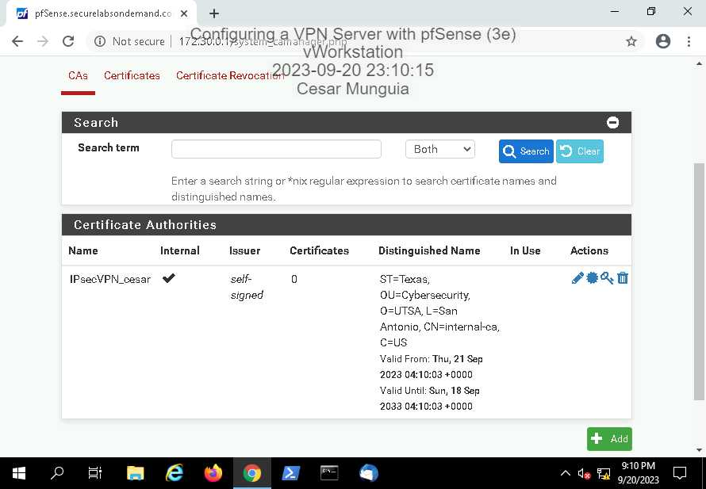

1. On the CAs page, I clicked the Certificates tab to open the Certificates page and begin the process of creating a server certificate.
2. On the Certificates page, I clicked the Add/Sign button to add a new server certificate.
3. At the Method menu, I did not change the default value (Create an internal Certificate).
4. In the Descriptive name field, I **typed IKEv2VPN_pfSense** to assign a label for this certificate within the pfSense Web GUI.
5. At the Certificate Authority menu, I **did not change** the default value (IPsecVPN_yourname).
6. At the Key Length menu, I **did not change** the default value (2048 bits).
7. At the Digest Algorithm menu, I **did not change** the default value (sha256).
8. At the Lifetime (days) field, I **did not change**the default value (3650 days, or approximately 10 years).
9. In the Common Name field, I **typed 202.20.1.1** to define the name of the host that this certificate will be assigned to.
10. **I accepted** the **default values** for Country Code, State or Province, City, Organization, and Organizational Unit.
11. From the Certificate Type menu, I **selected Server Certificate** to define the certificate's usage attributes.
12. At the Alternative Names section, I **selected IP Address**from the Type menu, then **typed 202.20.1.1** in the Value fieldto record the pfSense firewall-router's WAN-facing IP address as an alternative identifier for this certificate.
13. **I clicked** the **Save button** to return to the Certificates page.
14. **I made a screen capture showing the updated Certificates table**.

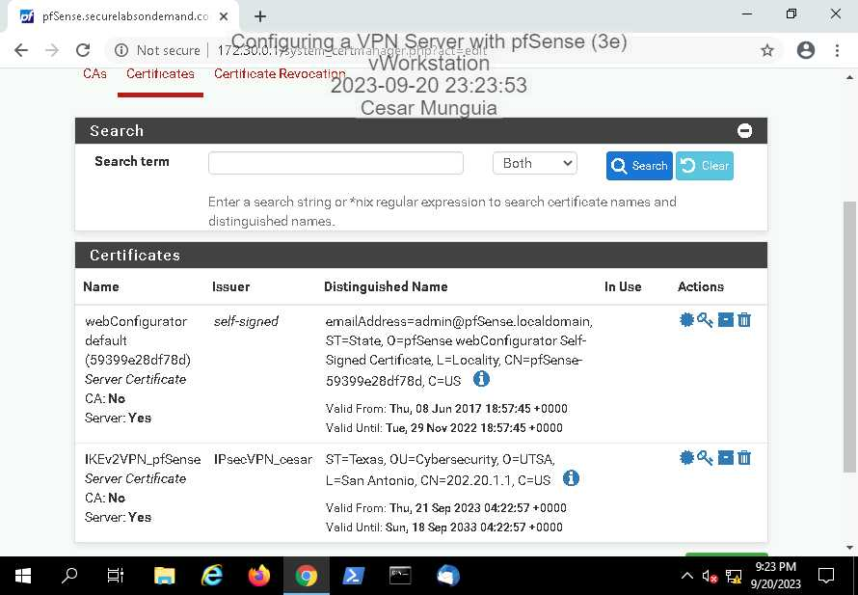

1. From the pfSense menu bar, I **clicked VPN** and **selected IPsec**to open the VPN / IPsec / Tunnels page.
2. On the Tunnels page, I **clicked** the **Mobile Clients tab** to open the Mobile Clients page and began the configuration.
3. In the Enable IPsec Mobile Client Support section, I **clicked** the **IKE Extensions checkbox** to activate this feature.
4. In the User Authentication box, I **clicked** the **Local Database item** to select it.
5. At the Group Authentication menu, I **did not change** the default value (none).
6. In the Virtual Address Pool section, I **clicked** the **checkbox**, then **typed 172.31.1.0** in the corresponding field and **accept 24** as default value in the subnet drop-down menu.
7. In the Network List section, I **clicked** the **checkbox** to provide a list of accessible networks to VPN clients.
8. **I did not change** any other settings
9. At the bottom of the Mobile Clients page, I **clicked** the **Save button**to save your changes and return to the Mobile Clients page.
10. On the Mobile Clients page, I **clicked** the **Apply Changes button** to apply the IPsec configuration changes.
11. On the Mobile Clients page, I **clicked** the **Create Phase 1 button** to open the Edit Phase 1 page and create a Phase 1 definition for the VPN tunnel.
12. From the Key Exchange version menu, I **selected IKEv2** to specify the version of the Internet Key Exchange protocol that your VPN will use.
13. At the IP version menu, I **did not change** the default value (IPv4).
14. At the Interface menu, I **did not change** the default value (WAN).
15. In the Description box, I **typed** **MobileIPsec** to assign a name for reference.
16. From the Authentication Method menu, I **selected EAP-MSChapv2** to specify Extensible Authentication Protocol-Microsoft Challenge Handshake version 2 as the authentication method.
17. At the My identifier menu, **I selected Distinguished name**, then **typed 202.20.1.1**, the WAN IP address, in the text box.
18. At the Peer identifier drop-down list, I **selected Any** to allow connections from any matching client.
19. From the My Certificate drop-down list, I **selected IKEv2VPN_pfSense** to specify the server certificate you created earlier in this lab.
20. In the Phase 1 Proposal (Encryption Algorithm) section, **do not change** the default values (AES using a Key Length of 256 bits with a SHA256 hash and 2048-bit Diffie-Hellman Group).
21. **I did not change** any other settings on this page.
22. At the bottom of the Edit Phase 1 page, I **clicked** the **Save button** to save your changes and return to the IPsec / Tunnels page.
23. On the IPsec / Tunnels page, **click** the **Apply Changes button** to apply the configuration changes.
24. **I made a screen capture showing the updated IPsec Tunnels table.**

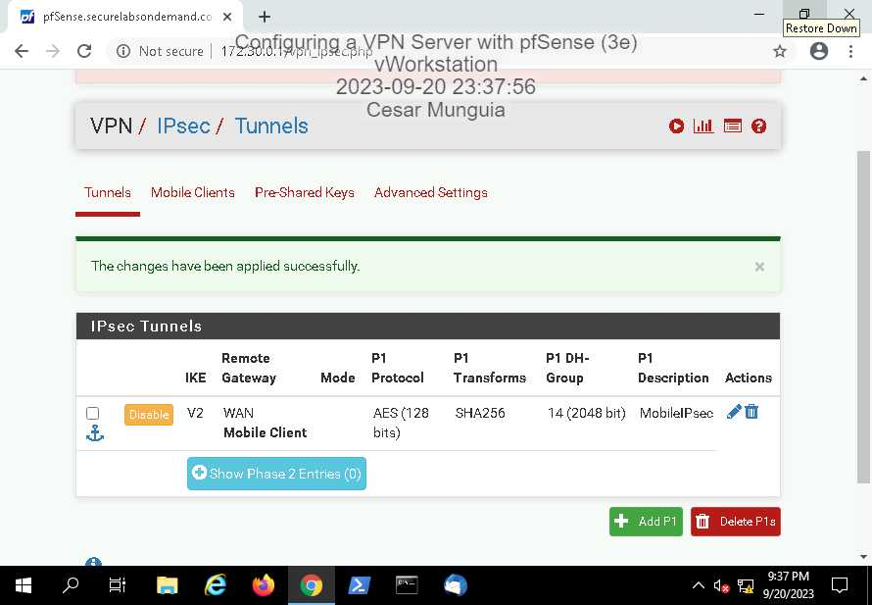

1. On the IPsec / Tunnels page, **I clicked** the **Show Phase 2 entries button**, then **clicked** the **Add P2 button**to open the Edit Phase 2 page and create a Phase 2 definition for the VPN tunnel.
2. On the Edit Phase 2 page, I **selected Network** from the Local Network drop-down menu, then **typed 0.0.0.0** in the text box to route all Internet traffic through the VPN tunnel.
3. In the Description field, **I typed MobileIPsec2** to add a description.
4. In the Phase 2 Proposal (SA/Key Exchange) section, I **did not change** the default Protocol (ESP).
5. From the AES Encryption Algorithms drop-down menu, I **selected 256 bits** to specify the key length.
6. In the Hash Algorithms section, I **clicked** the **SHA1 checkbox**, so that both SHA1 and SHA256 are selected.
7. From the PFS key group drop-down menu, I **selected off** to disable PFS.
8. **I did not change** any other settings on this page
9. At the bottom of the Edit Phase 2 page, I **click** the **Save button** to save my changes and return to the IPsec / Tunnels page.
10. On the IPsec / Tunnels page, I **clicked** the **Apply Changes button** to apply the configuration changes.
11. On the IPsec / Tunnels page, I **clicked** the **Pre-Shared Keys tab** to open the Pre-Shared Keys page.
12. On the Pre-Shared Keys page, I **clicked** the **Add button** to open the Pre-Shared Keys / Edit page and create a new pre-shared key.
13. In the Identifier field, I **typed remoteworker01**.
14. From the Secret type menu, I **selected EAP** (Extensible Authentication Protocol), matching the framework chosen for Phase 1 authentication.
15. In the Pre-Shared Key box, I **typed password1** to define the key value.
16. At the bottom of the Pre-Shared Keys / Edit page, I **clicked** the **Save button** to save your changes and return to the Pre-Shared Keys page.
17. On the Pre-Shared Keys page, I **clicked** the **Apply Changes button** to apply your configuration changes.
18. **I made a screen capture showing the updated Pre-Shared Keys table**.

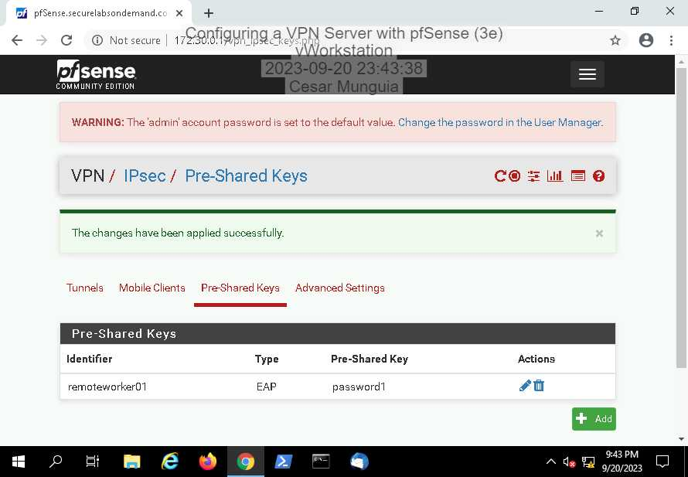

### Part 2: Configure a Firewall Rule for VPN traffic

1. From the pfSense menu bar, I **clicked Firewall** and **selected Rules** to open the Rules / WAN page.
2. On the Rules / WAN page, I **clicked** the **IPsec tab** to open the Rules / IPsec page.
3. On the Rules / IPsec page, **click** the **right-most Add button** to open the Firewall / Rules / Edit page and add a rule to direct IPsec traffic.
4. On the Rules / Edit page, **verify** that the default Action is Pass and the Interface is IPsec.
5. From the Protocol menu, **select Any** to allow any protocol through the firewall.
6. In the Description box, **type IPsec Open** to provide a description for this rule.
7. At the bottom of the Edit page, **click** the **Save button** to save your changes and return to the Rules / IPsec page.
8. On the Rules / IPsec page, **click** the **Apply Changes button** to apply the new rules to the pfSense firewall.
9. **Make a screen capture showing the updated IPsec Rules table**.
10. **Close** the **pfSense browser window**.

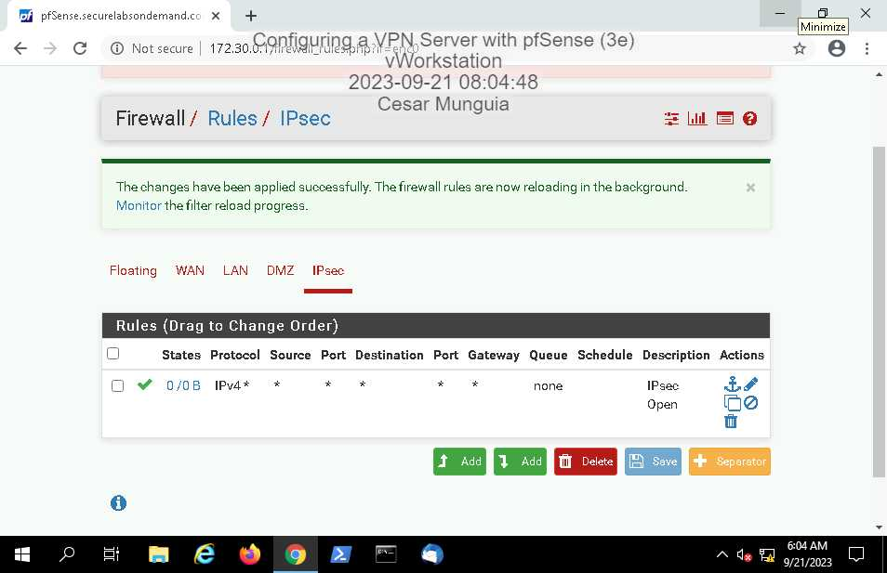

# Section 2: Applied Learning

### Part 1: Configure an OpenVPN VPN Server

1. From the vWorkstation, **open** a new **browser window** and **navigate** to the pfSense Web GUI at **172.30.0.1**.
2. **I logged in** to the pfSense Web GUI using the following credentials. Username: admin, password: pfsense

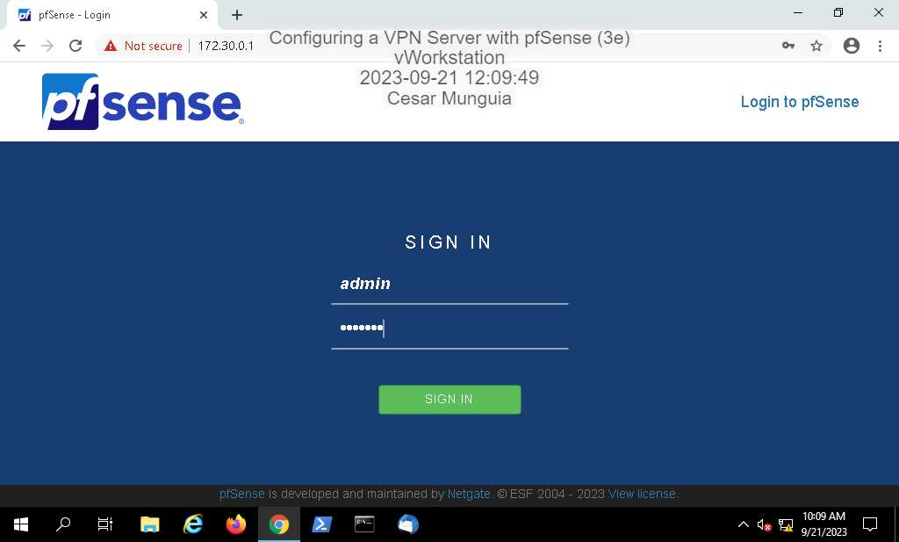

1. From the pfSense menu, **select VPN > OpenVPN** to open the VPN / OpenVPN / Servers page.

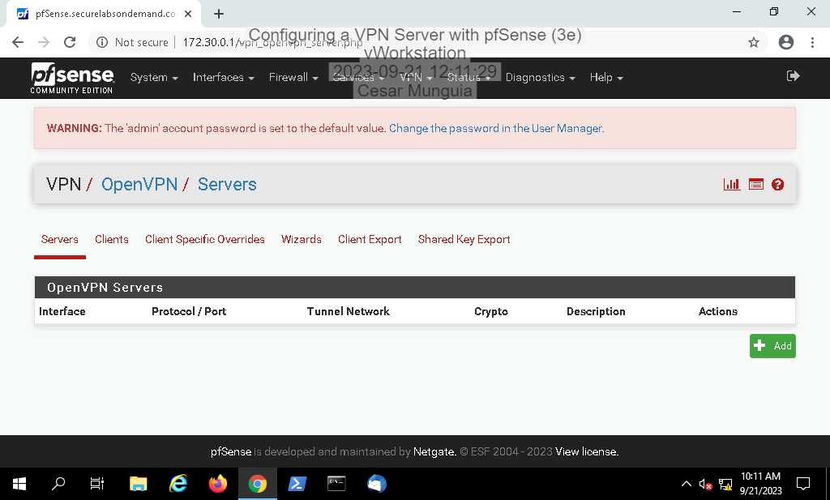

1. On the Servers page, **click** the **Wizards tab** to open the OpenVPN Remote Access Server Setup wizard.
2. At the Select an Authentication Backend Type page, **accept the default value** (Local User Access) and **click Next** to continue.

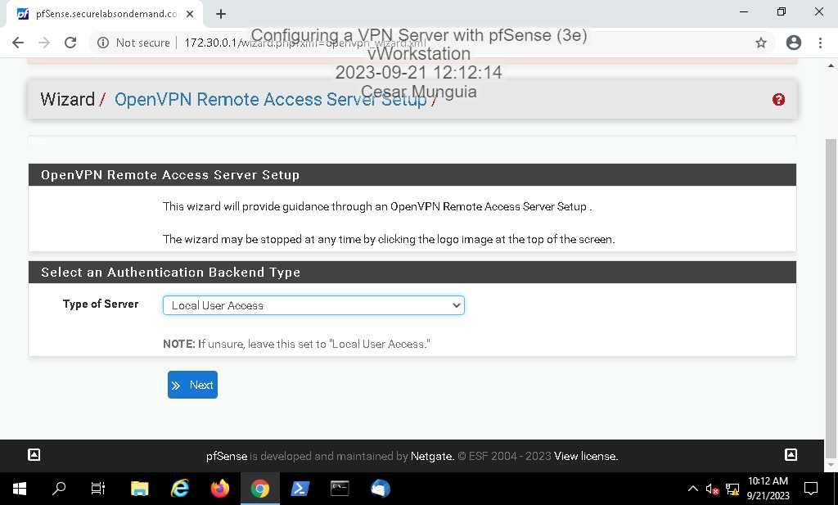

1. At the Certificate Authority Selection page, **click Add new CA** to continue.

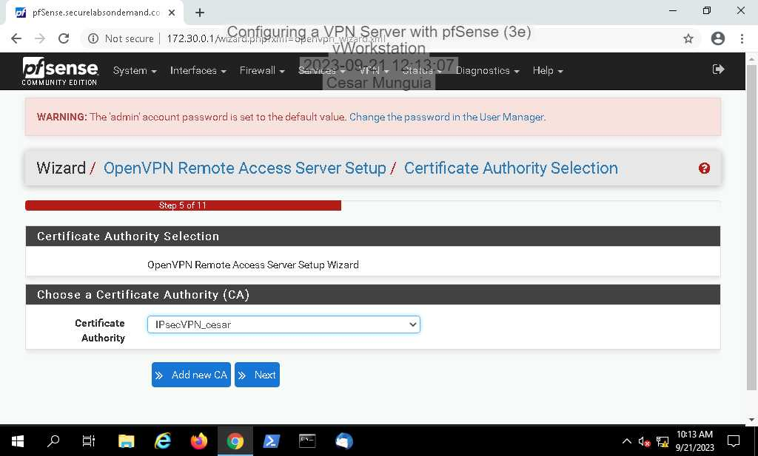

1. At the Create a New Certificate Authority (CA) Certificate page, **type OpenVPN_CA_*yourname*** in the Descriptive name field, replacing *yourname* with your own name.
2. **Accept** the **default values** for Key length and Lifetime.
3. In the Country Code field, **type US** to define the United States as the country.
4. In the State or Province field, **type yourState**, replacing yourstate with your own home state.
5. In the City field, **type *yourCity***, replacing *yourcity* with the city in which you are currently physically located.
6. In the Organization field, **type *yourSchool***, replacing *yourschool* with the name of the institution through which you are completing this course.
7. **Make a screen capture** showing the**CA configuration form.**

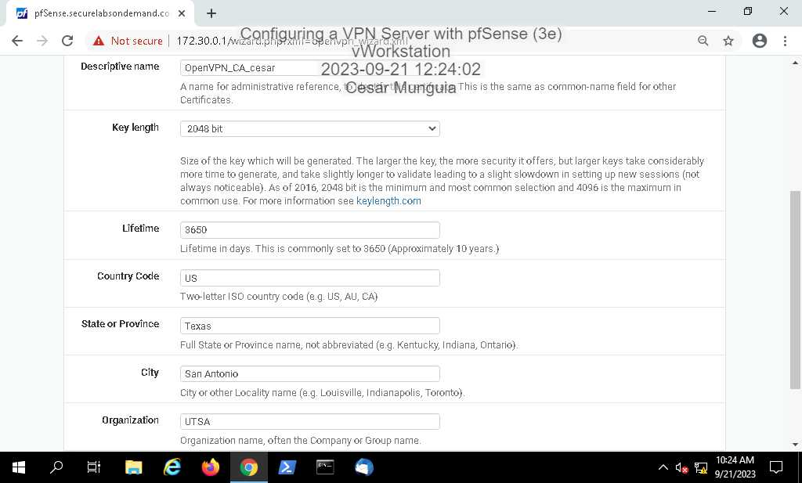

1. **Click** the **Add new CA button** to continue to the next page.
2. At the Server Certificate Selection page, **click Add new Certificate** to continue.

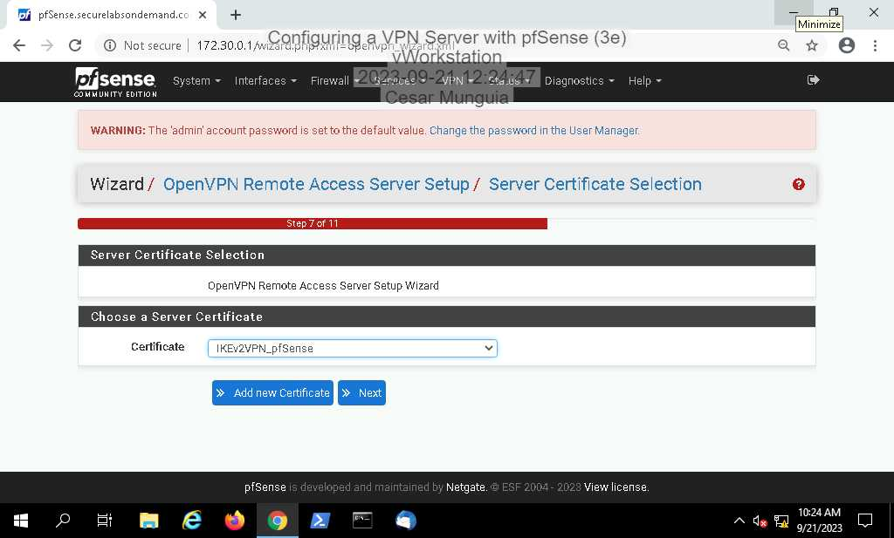



1. At the Create a New Server Certificate page, **type OpenVPN_SC_*yourname*** in the Descriptive name field, replacing *yourname* with your own name.
2. **Accept** the **default values** for the remaining settings.

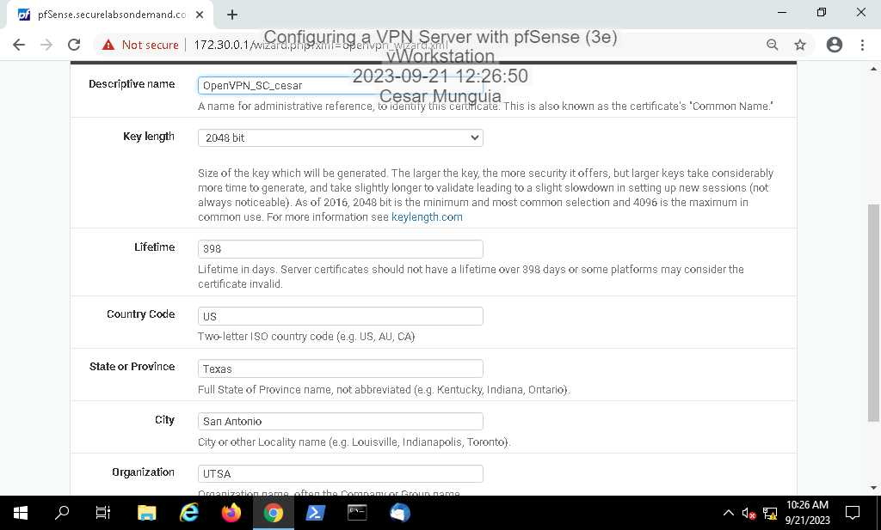

1. **Click**the **Create new Certificate** **button** to continue to the next page.
2. At the Server Setup page, **accept**the **default settings** in the General OpenVPN Server Information section and **type OpenVPN Server** in the Description box.

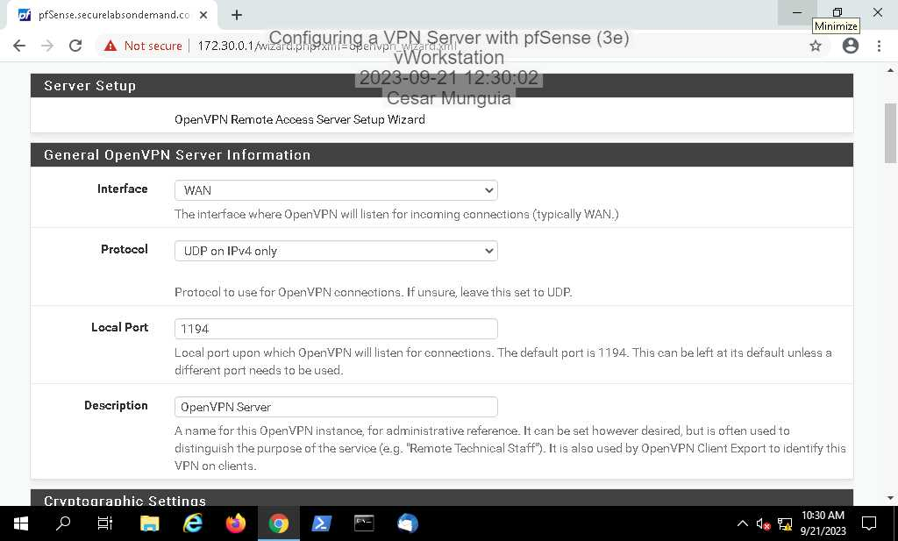

1. In the Cryptographic Settings section, **un-check** the **TLS Authentication checkbox** to disable authentication of TLS packets.
2. Because this is a MVD (Minimal Viable Deployment) setup, **accept**the **default value** for the fields listed in the following table.

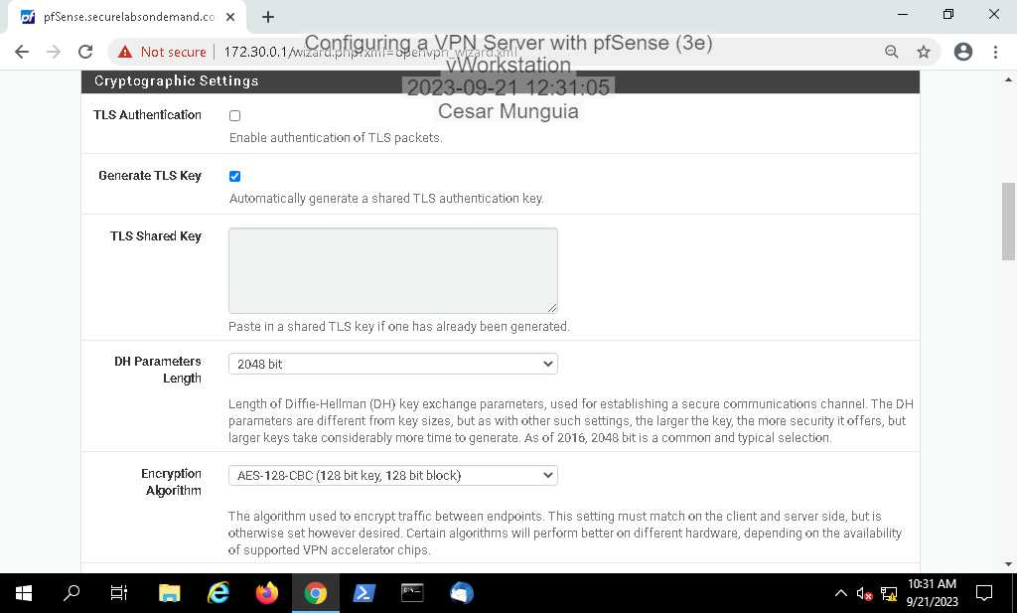



1. At the Tunnel Settings section, **type 172.31.1.0/24** in the Tunnel Network field.
2. **Uncheck** the **Redirect Gateway checkbox**.
3. In the Local Network box, **type 172.30.0.0/24** to specify the network(s) accessible to VPN clients
4. In the Concurrent Connections box, **type 2** to set the number of simultaneous users

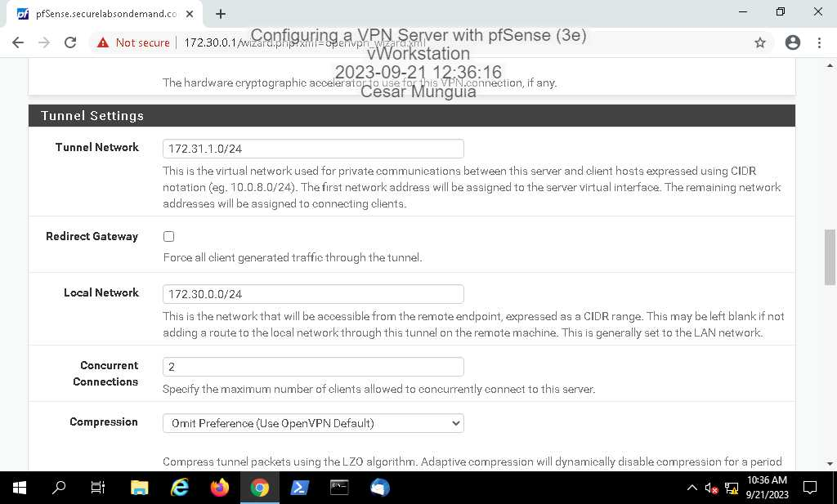

1. **Click** the **Inter-Client Communication checkbox** to allow communication between VPN clients connected to this server.
2. **Make a screen capture** showing the **Tunnel Settings section**.

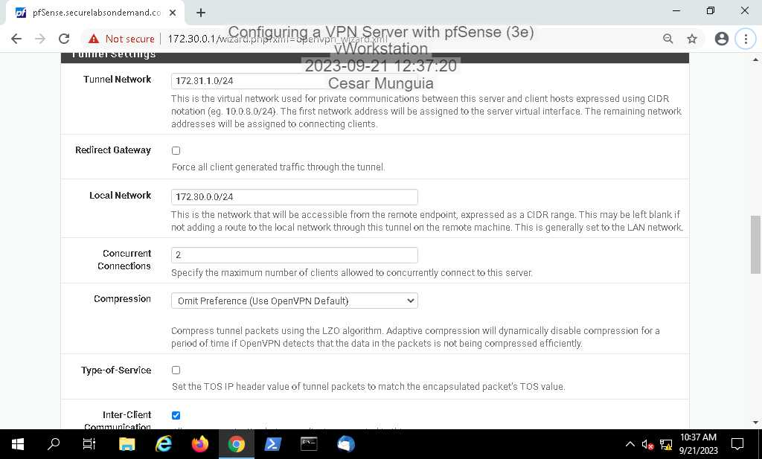

1. At the Client Settings section, **type securelabsondemand.com** in the DNS Default Domain field to provide a default domain name for VPN clients
2. In the DNS Server 1 field, **type 172.30.0.1** to specify the LAN interface of the OpenVPN server.
3. **Make a screen capture** showing the **Client Settings section.**

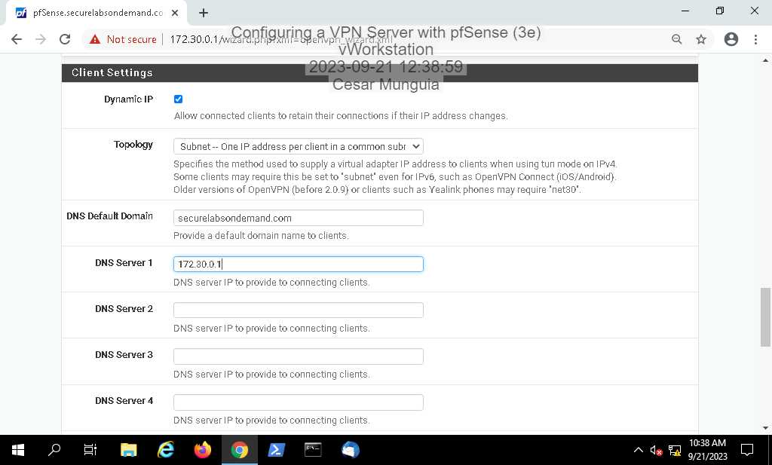

1. **Click Next** to continue to the Firewall Rule Configuration page.

### Part 2: Configure a Firewall Rule for VPN Traffic

1. On the Firewall Rule Configuration page, **click Next**to accept the default firewall rules that will allow traffic through the firewall.

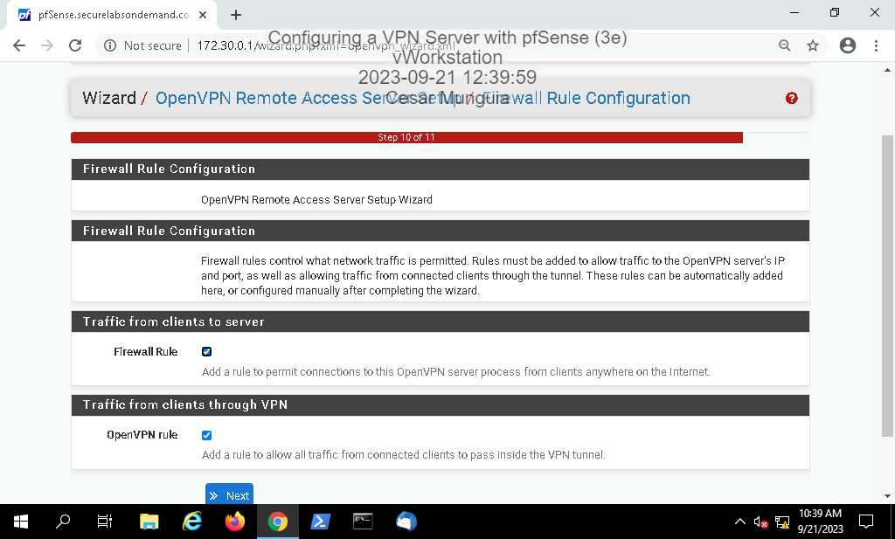

1. **Make a screen capture**showing the **completed OpenVPN configuration**.

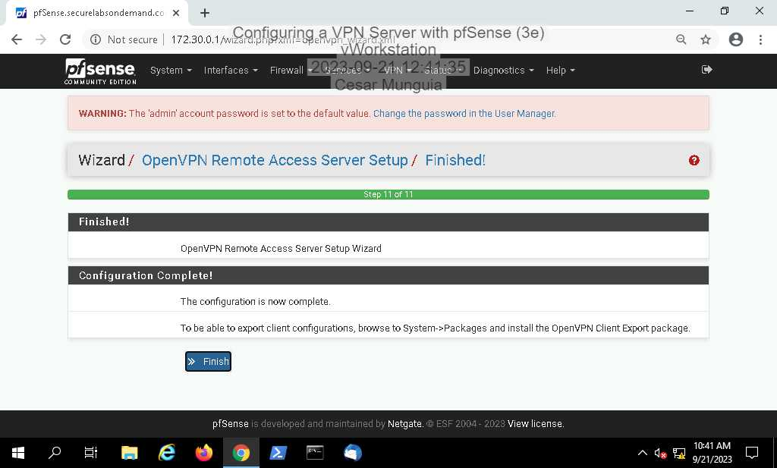

1. **Click Finish** to return to the VPN Servers table.
2. From the pfSense menu, **select Firewall > Rules** to view the new OpenVPN firewall rule on the WAN Rules table.
3. **Make a screen capture** showing the **OpenVPN rule on the WAN Rules table.**

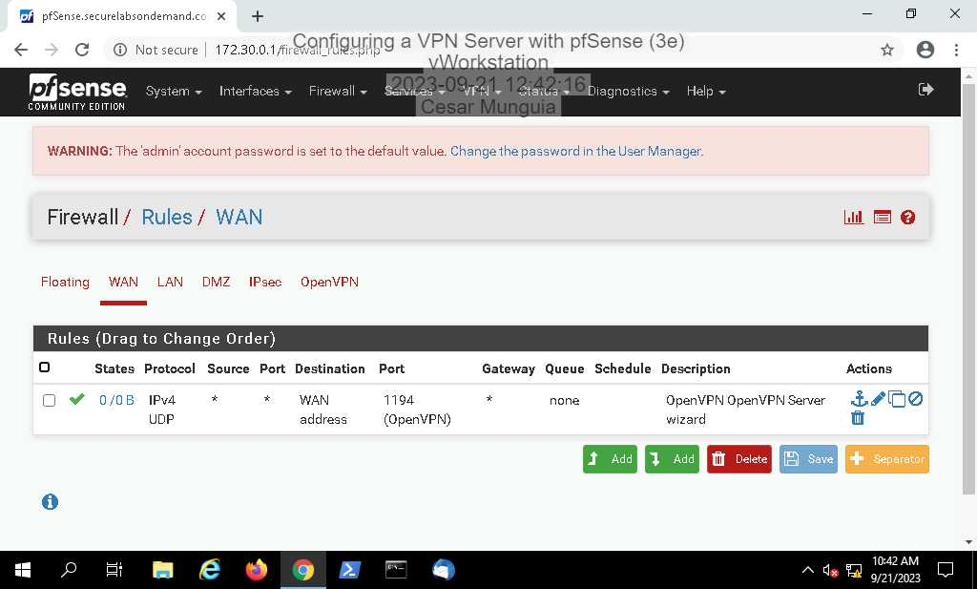

1. **Make a screen capture** showing the **OpenVPN rule on the OpenVPN Rules table**.

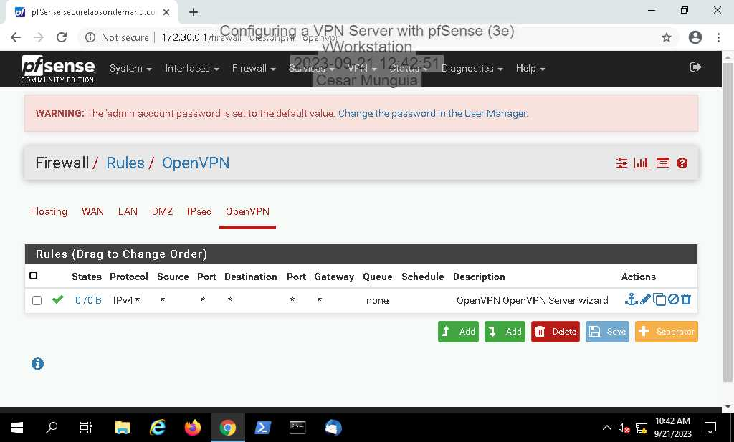

# Section 3: Challenge and Analysis

### Part 1: Enable IP Roaming for Remote VPN Clients

Part 1 requires me to enable the MOBIKE option support for my IPsec tunnel in pfSense. I had to do a little bit of research in the Internet to find this out. At first, I was confused about what it was asking me to do because I didn’t know if I had to make another VPN with IPsec and then enable that option. However, I realized that I just had to adjust some configurations in the VPN I had previously made in Section 1. I went to VPN > IPsec > Mobile Clients, and then I went ahead and edited the configurations of Phase 1 since in my research I found out that the MOBIKE option resides there. Under the Phase 1 configurations I scrolled down to the Advanced Options and found the MOBIKE option and just enabled it. Here is a screenshot for proof:

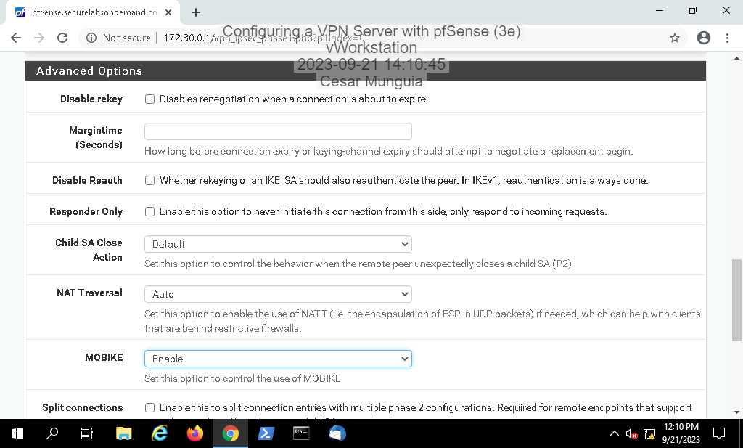



### Part 2: Create Explicit Firewall Rules for an IPsec VPN

I disabled the IPsec automatic rule creation in Pfsese by going to System > Advanced > Firewall & NAT. I scrolled down and checked the corresponding box.

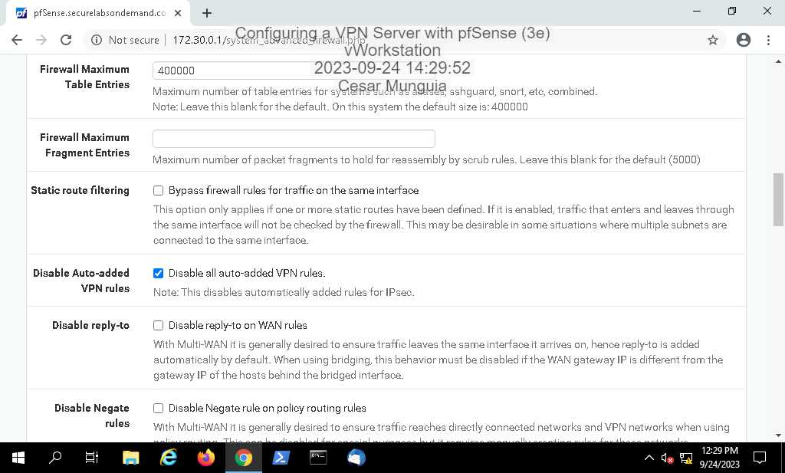

Then I added the respective rules for the IPsec VPN connections. First rule uses protocol ESP with destination to WAN address. Second rule uses TCP/UDP with destination to WAN address and using port 500. The third rule uses TCP/UDP protocol with destination to WAN address and using port 4500.

